DMWA Lab – 5

Q1

FP_growth Rule in weka

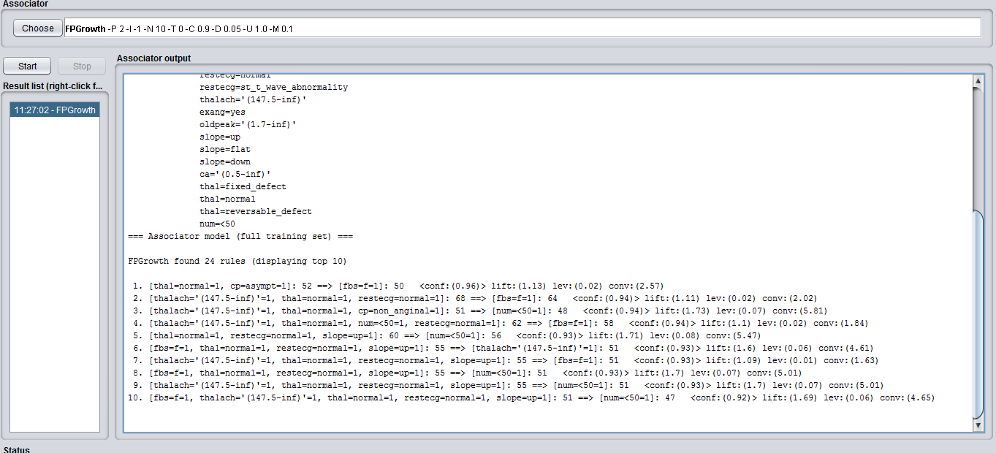

Q2

import pandas as pd  
import numpy as np

import pyfpgrowth

df= pd.read_csv(“ transaction_data.csv”)

patterns = pyfpgrowth. find_frequent_patterns(transactions, 10)

rules = pyfpgrowth. generate_association_rules(patterns,0.8)

def support_count(rhs):

count=0

rhs= set(rhs)

for j in df[‘items’]:

j=set(j)

if(rhs.issubset(j)):

count=count+1

return count

rhs_support = []

for I in rules_df[‘Consequent’]:

a=support_count(i)

rhs_support.append(a/len(df))

rules_df[‘RHS_support’] = rhs_support

rules_df[‘lift’] = rules_df[‘Confidence’]/rules_df[‘RHS_support’]

rules_df[‘Conviction’] = (1-rules_df[‘RHS_support’])/(1-rules_df[‘Confidence’])

Q3

Linear Regression using Weka

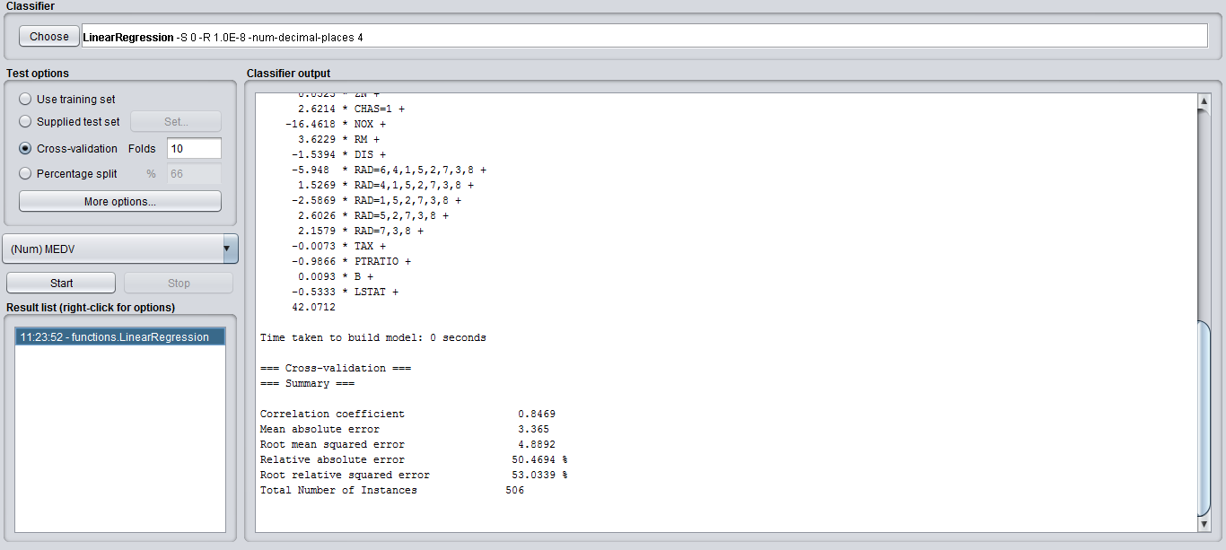

Q4

KNN using Weka on IRIS dataset

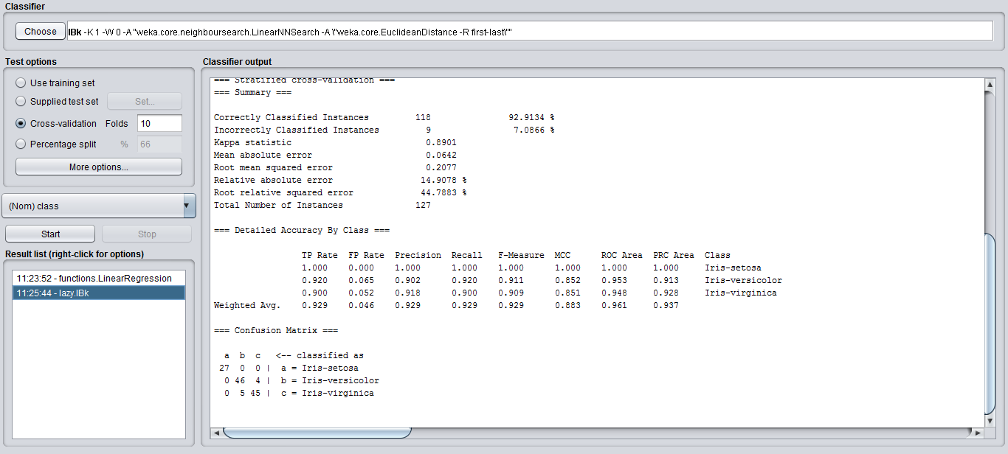

Code-:

from math import sqrt  
  
def euclidean_distance(row1, row2):  
distance = 0.0  
for i in range(len(row1)-1):  
distance += (row1[i] - row2[i])**2  
return sqrt(distance)  
  
def get_neighbors(train, test_row, num_neighbors):  
distances = list()  
for train_row in train:  
dist = euclidean_distance(test_row, train_row)  
distances.append((train_row, dist))  
distances.sort(key=lambda tup: tup[1])  
neighbors = list()  
for i in range(num_neighbors):  
neighbors.append(distances[i][0])  
return neighbors

def predict_classification(train, test_row, num_neighbors):  
neighbors = get_neighbors(train, test_row, num_neighbors)  
output_values = [row[-1] for row in neighbors]  
prediction = max(set(output_values), key=output_values.count)  
return prediction